GHOULS ON PARADE!

It is getting close to that time of year again. The fairies, witches, princesses, superheroes and all ghouls in between are ready for trick or treating. We would once again like to plan a parade for all the local daycare centers and homeschools.

When: Thursday, October 31st at 10:00 a.m.

Where: We will meet at the Hamilton Public Library (312 N. Davis St.) to kick off the parade with a story walk and the first stop in the trick or treating extravaganza. The parade will trick or treat at participating businesses from the Library to Dollar General on the **East side of the street only** (to keep street-crossing for the little ones to a minimum).

In case of Bad Weather, we will ask the participating businesses to come to the library basement and the children will trick or treat in the basement.

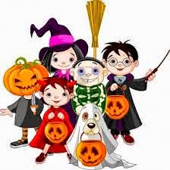

Please contact Sonja Farnsworth at the Hamilton Public Library at 816-583-4832 or at [hamiltonpubliclibrary@gmail.com](mailto:hamiltonpubliclibrary@gmail.com) with any questions